***Need a gateway to happy future? Check your credit score now***

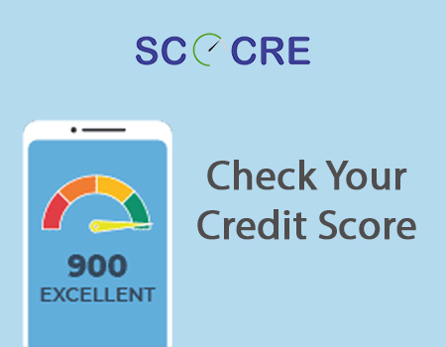

There are a lot of people who just flip aside the [credit report](https://scocre.com/blogs/credit-report-and-its-importance.php) when they receive it from the credit bureaus without analysing their scores. Most people are not worried if the scores are good or bad or if there are aspects that need to be worked upon.

But we warn you that people who practice this often regret it in the days to come when they really need money and apply for loans. So, believe us when we tell you that it is necessary to keep an eye on your score on a regular basis as it will help you have a great financial future. Good scores can literally get the world at your feet as it will convey a better credit look about you to your lenders.

So, here are a few more reasons why you should [check your credit score](https://scocre.com/register) and how they become a gateway to help you live a better life.

**Helps negotiate loan conditions better**: One of the major benefits of good credit scores is that it enables you to get an upper hand to negotiate with lenders in terms of loan interest rate, tenure and so on. This means that if the [credit scores](https://scocre.com) are brimming and shining, and you are aware of it, you can talk it out with the lender to lower the interest rate and can get a convenient term period, which means that the less money you pay in the form of interest. The faster you'll pay off the debt and the more money you have for other expenses. Also, if the scores are good, the processing and disbursal of all types of loans gets completed within no time.

**Better knowledge of your finances:** If you check your credit score on a regular basis, it will help you get a better understanding of your monetary status and you also get to know the areas where you need to pull yourself up. It helps you understand if you have been in impulsive investor or are overusing the available credit limit or need to pay your bills before the billing cycle.

**Reduce monetary disasters:** The exercise of thoroughly scanning your scores reduces the possibilities of fraudulent activities, discrepancies, incorrect entries, and more. Also, it helps you spot wrong information that has been accidently put on your report on account of mistaken identities or identical names.

**Conclusion**

It is important to understand that many people skip reviewing their credit scores and they could be doing it for various reasons. They could do it either because they are too busy with their daily chores, or probably they do not know how to read the report or they are yet to realise the importance of going through it minutely. But whatever the reason be, it is a huge mistake they make which reflects in the form of poor scores.

So, if you too are not in the habit to [check your credit score](https://scocre.com/login), then develop it fast as it is an important step to a happy financial future.